380W BEAM MOVING HEAD

USER MANUAL

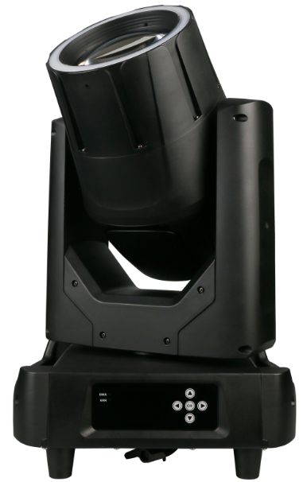

Please read and keep this manual carefully for further use!

Thank you for buying our professional Beam moving head.
This user manual includes important information for installation and operation, so please read this user manual carefully before installation and operation, and keep this user manual well for further use.
In order to install , operate, and maintain the lighting safety and correctly. We suggest that the installation and operation should be done by the verified technician and follow the instruction strictly.
Spare part includes:
Name | QTY | Unit
Fixture | 1 | PC
User manual | 1 | PC
Power cable | 1 | PC
DMX signal cable | 1 | PC
Safety rope | 1 | PC

Please check carefully that there is no damage caused by transportation. Should there be any, consult your local dealer.
Cautions
Before delivery, this device has passed strict inspection, Please follow the user manual strictly for operation, if this fixture is damaged by improper operation and mistake, the fixture will be out of warranty, and manufacture or dealer won’t be responsible for it. In case of any technology change in this manual,we won’t advise in further .



CAUTION!

Keep this device away from rain and moisture!

Unplug mains lead before opening the housing!

Warning!

Silkscreen symbol on light
Damages caused by the disregard of this user manual are not subject to warranty. The dealer will not accept liability for any resulting defects or problems.

Installation
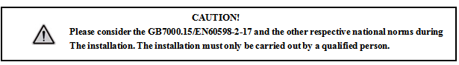

► This fixture is not suitable for direct installation on combustible material surface, please keep the fixture surface at least 0.5m from any combustible material.

► If you use the quick lock cam in hanging up the fixture, please make sure the quick lock fasteners turned in the quick lock holes correctly.
►The applicable temperature for the fixture is between -25°C to 45°C. Do not use the lighting under or above this temperature range.
►The truss for hanging the fixture should be able to hold 10 times weight of this fixture and no deformation after 1 hour hang.
►Please don’t stand under the fixture when install, uninstall, move or repair the fixture.
►Please ensure the light is connected correctly and invite professional technician to check and confirm the electrical data before installation.
►Please invite professional technician to check the fixture and installation each year.
Rigging：

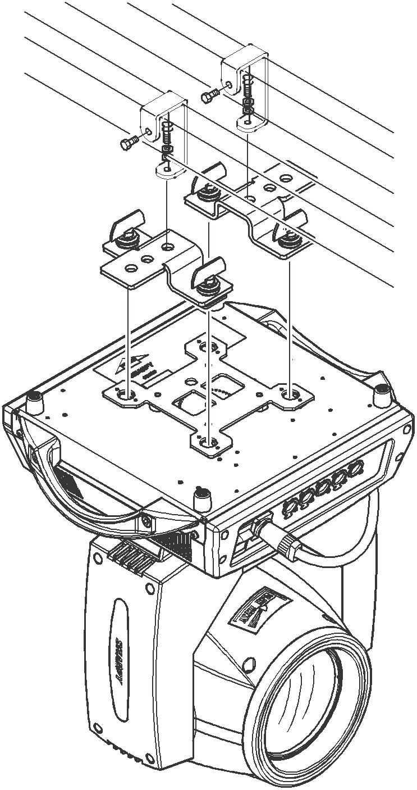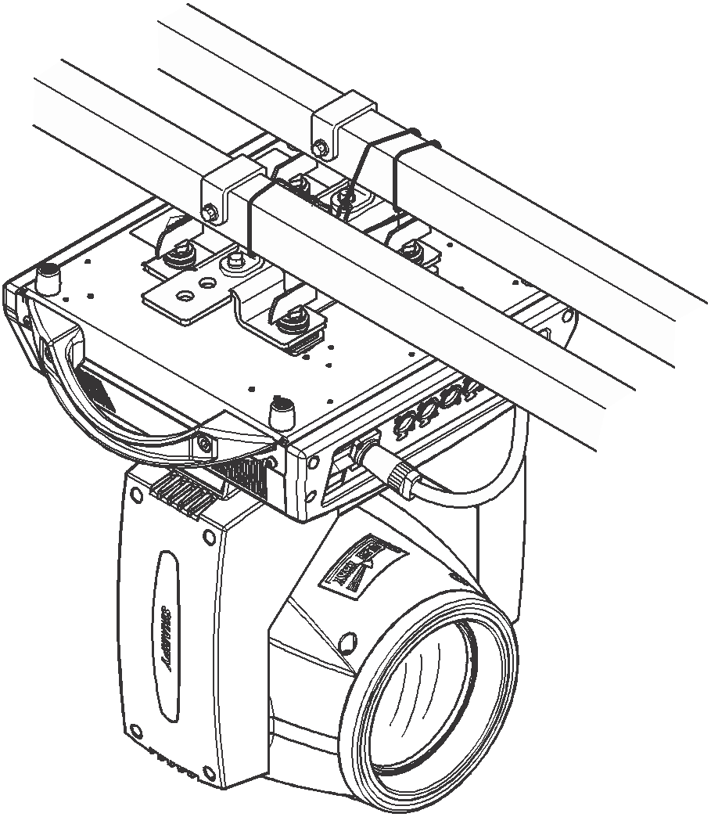

Insert the quick-lock fasteners of the first holder into the respective holes on the bottom of the device.Tighten the quick-lock fasteners fully clockwise.
Fix the clamp on truss or other fixture bracket.
Pull the safety rope through the holes on the bottom of the base and fasten it on the truss or other fixing point.
Note:This step is quite important to ensure that fixture will not drop down for the clamp damage.

Product specification

Voltage：100-240V，50/60HZ；
Power Consumption：500W；
Lamp: Chinese lamp 380W
Fuse:8A/250V，￠5*20
DMX Channel: 19CH
Operation mode: master-slave/DMX/Auto
Focus: Yes
Fixed gobo: 12 gobos+open+ 5 glass gobos
Strobe: 25Hz
Color: 14 colors+open
Prism 1: 8-facet
Prism 2: 8+16-facet
Pan: 540°
Tilt: 270°
Frost / Six-color effect: Yes
RDM: Yes

Display and operation

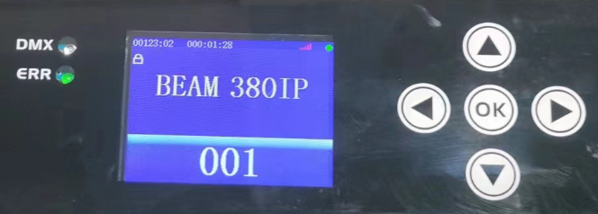

DMX | DMX signal indicator
AUDIO | Sound control indicator
Up | menu up selection
Down | menu down selection
Left | Menu left to select/return
Right | Menu right to select
ENTER | Confirm button
time on the left | Total system usage time
time on the right | Total time of this power-on
Vertical signal at the top | Current DMX signal strength  Red: No signal / White: Current signal strength
Square icon in the upper right corner | Green: OK, no errors
Square icon in the upper right corner | Red: There is an error (click the icon or "Information Menu/Error Information/View" to view the error

System Menu description:

反向 | Reve | Invert the screen display
退出 | Exit | Exit to the main interface
Lang | 语言 | Choose from Chinese or English
标准设置 | Standard | Address code and some common function settings
高级设置 | Advanced | Main parameter factory settings
系统信息 | Info | Error, software version, etc. information display
手动编程 | Program | Manually control the operation, or edit the user program
测试运行 | Perform | Automatic operation or Sound-controlled operation of built-in programs, user programs
系统复位 | Reset | System reset to initial position

Display Setting:
Standard | Default set | Enter | Default set
Standard | Address | 001-512 | Set address code
Standard | DMX mode | Mode1  Mode2  Mode3  Mode4 | Select DMX control mode
Standard | Effect mode | No/Yes | effect wheel automatically finds the shortest distance to rotate and run
Standard | Started lamp | Off/on | Choose to turn the bulb "on" or "off" each time
Standard | Switch lamp | Off/on | Turn on the lamp manually
Standard | No signal | Clear  Hold | Keep DMX value or clear DMX channel value when no DMX signal
Standard | UI Color | Green  Blue  Golden  Gray | Choose screen menu color
Standard | Show time | No/Yes | Display the runtime timer on the main screen
Standard | Brightness | 000-255 | Adjust screen brightness
Standard | Screensaver | Off/on | Turn off the screen when no touch and key operation
Standard | XY encoder | No/Yes | Cancel or use the XY auto-correction function
Standard | X inversion | No/Yes | Select X-axis to run forward or reverse
Standard | Y inversion | No/Yes | Select Y-axis to run forward or reverse
Standard | Focus inversion | No/Yes | Choose to run the focus forward or reverse
Standard | Zoom inversion | No/Yes | Choose to run the Zoom forward or reverse
Advanced | This is the main parameter setting of the fixture and requires permission
Info | Error List | No error/View | If there are no errors or there are errors, click OK to view the errors
Info | System ver | Vxxxxxxx | System version information
Info | Serial NO. | xxxxxxxx | Equipment factory number
Info | SYS timer | 00000.0H | Total system running time (hours)
Info | Run timer | 000:00 | Running time after this power-on (hours)
Info | Lamp timer | 00000.0H | The total time of lamp on (hours)
Info | Equip TEMP | 000 | The temperature of the main part (requires device support)
Info | Head TEMP | 000 | The temperature of the head (requires device support)
Info | FAN 1 Speed | 0000 RPM | fan 1 speed (requires equipment support)
Info | FAN 2 Speed | 0000 RPM | fan 2 speed (requires equipment support)
Perform | Run mode | Auto/Sound | Run selected programs Auto or Sound
Perform | Run speed | 255 | Set the speed of Auto running
Perform | Run cross | 255 | Set run cross for Auto or Sound
Perform | Built-in 1 | Off/on | built-in test program 1
Perform | Built-in 2 | Off/on | built-in test program 2
Perform | User PRO 1 | Off/on | User-programmed program 1
Perform | User PRO 2 | Off/on | User-programmed program 2
Perform | User PRO 3 | Off/on | User-programmed program 3
Perform | User PRO 4 | Off/on | User-programmed program 4
Perform | Circle shape | Off/on | (reserve)
Perform | Square shape | Off/on | (reserve)
Perform | Shape range | 000 | (reserve)
Perform | Sound DB | 000 | Adjust the sound control sensitivity
Program | This function can program up to 4 user programs, and the 4 programs can be run in series, that is to say, the programmed 4 programs can be switched to ON at the same time in the "User-Pro" function. Go to program 2, go to program 3, then program 4, then loop back to program 1, and so on. Of course, it can also be run as a single option.
Reset | Reset to initial position

19 DMX channel

16CH | Function | Value | Details
1 | Color whee | 000-004  005 -009  010 - 014  015 - 019  020 - 024  025 - 029  030 - 034  035 - 039  040 - 044  045 - 049  050 - 054  055 - 059  060 - 064  065 - 069  070 - 074  075 - 079  080 - 084  085 - 089  090 - 094  095 - 099  100 -104  105 -109  110 -114  115 -119  120 -124  125-129  130 -134  140- 144  145- 149  150- 200  201- 255 | White  White+Color 1  Color 1  Color 1+color 2  Color 2  Color 2+color 3  Color 3  Color 3+color 4  Color 4  Color 4+color 5  Color 5  Color 5+color 6  Color 6  Color 6+color 7  Color 7  Color 7+color 8  Color 8  Color 8+color 9  Color 9  Color 9+color 10  Color 10  Color 10+color 11  Color 11  Color 11+color 12  Color 12  Color 12+color 13  Color 13  Color 14  Color 14+White  Reverse flow (from fast to slow)  Forward flow (from slow to fast)
2 | Strobe | 000-003  004-103  104-107  108-207  208-212  213-251  252-255 | Shutter closed  Strobe from slow to fast  Open the shutter  Pulse strobe from slow to fast  Open  Random strobe from slow to fast  Open → (controlled by the dimming channel)
3 | Dimmer & RGB | 000-255 | dimmer from dark to bright
4 | Gobo wheel | 000 - 004  005 - 009  010 - 014  015 - 019  020 - 024  025 - 029  030 - 034  035 - 039  040 - 044  045 - 049  050 - 054  055 - 059  060 - 064  065 - 069  070 - 074  075 - 079  080 - 084  085 - 089  090 - 129  130 - 134  135 - 169  170 - 174  175 - 179  180 - 184  185 - 189  190 - 194  195 - 199  200 - 204  205 - 209  210 - 214  215 - 219  220 - 224  225 - 229  230 - 234  235 - 239  240 - 244  245 - 249  250 - 255 | White  gobo 1  gobo 2  gobo 3  gobo 4  gobo 5  gobo 6  gobo 7  gobo 8  gobo 9  gobo 10  gobo 11  gobo 12  gobo 13  gobo 14  gobo 15  gobo 16  gobo 17  Forward flow (from slow to fast)  Stop  Reverse flow (from fast to slow)  gobo 1 shake slow to fast  gobo 2 shake slow to fast  gobo 3 shake slow to fast  gobo 4 shake slow to fast  gobo 5 shake slow to fast  gobo 6 shake slow to fast  gobo 7 shake slow to fast  gobo 8 shake slow to fast  gobo 9 shake slow to fast  gobo 10 shake slow to fast  gobo 11 shake slow to fast  gobo 12 shake slow to fast  gobo 13 shake slow to fast  gobo 14 shake slow to fast  gobo 15 shake slow to fast  gobo 16 shake slow to fast  gobo 17 shake slow to fast
5 | Prism1 | 000-31  32-255 | no prism  prism 1
6 | Prism1 rotation | 000-127  128-190  191-192  193-255 | Prism angle adjustment  Reverse rotation (fast to slow)  Stop  Forward rotation (slow to fast)
7 | Prism 2 | 000-31  32-255 | no prism  prism 2
8 | Prism2 rotation | 000-127  128-190  191-192  193-255 | prism angle adjustment  Reverse rotation (fast to slow)  Stop  Forward rotation (slow to fast)
9 | Focus | 000-255 | Pattern clarity from near to far
10 | pan | 000-255 | 0-540 degree
11 | pan fine | 000-255 | 0-1.2 degree
12 | tilt | 000-255 | 0-270 degree
13 | tilt fine | 000-255 | 0-1.2 degree
14 | XY speed | 000-255 | speed fast to slow
15 | Frost & 6-color effect | 000-127  128-191  192-255 | no function  6-color effect  Frost
16 | Lamp control | 000-025  100-105  200-205  250-255 | no function  Lamp off  Lamp on  all motors reset
17 | RGB strobe | 000-255 | Strobe from slow to fast
18 | RGB effect | 000-001  002-005  006-010  011-015  016-020  021-025  026-029  030-048  049-054  055-058  059-063  064-068  069-073  074-078  079-087  088-092  093-097  098-102  103-107  108-112  113-116  117-122  123-126  127-131  132-136  137-140  141-144  145-149  150-155  156-160  161-165  166-170  161-165  166-174  175-179  180-184  185-189  190-194  195-199  200-203  204-208  209-213  214-218  219-223  224-228  229-232  233-237  238-242  243-247  248-252  253-255 | Red 1  Green 2  Blue 3  Yellow 4  Rose 5  Light blue 6  White 7  Color jump 8  Effect 9  Effect 10  Effect 11  Effect 12  Effect 13  Effect 14  Effect 15  Effect 16  Effect 17  Effect 18  Effect 19  Effect 20  Effect 21  Effect 22  Effect 23  Effect 24  Effect 25  Effect 26  Effect 27  Effect 28  Effect 29  Effect 30  Effect 31  Effect 32  Effect 33  Effect 34  Effect 35  Effect 40  Effect 41  Effect 42  Effect 43  Effect 44  Effect 45  Effect 46  Effect 47  Effect 48  Effect 49  Effect 50  Effect 51  Effect 52  Effect 53  Effect 54  Effect 55
19 | RGBeffect Speed | 0-255 | Speed from slow to fast

Gobo Wheel
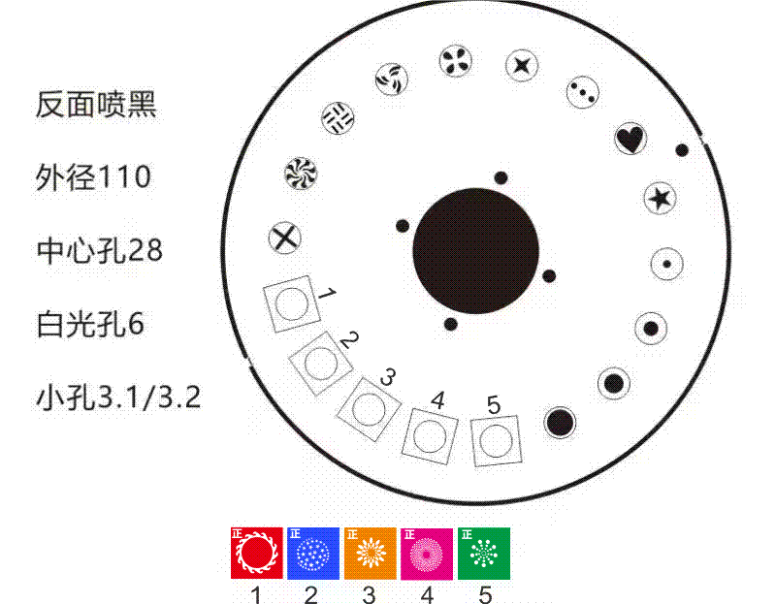
Color Wheel:
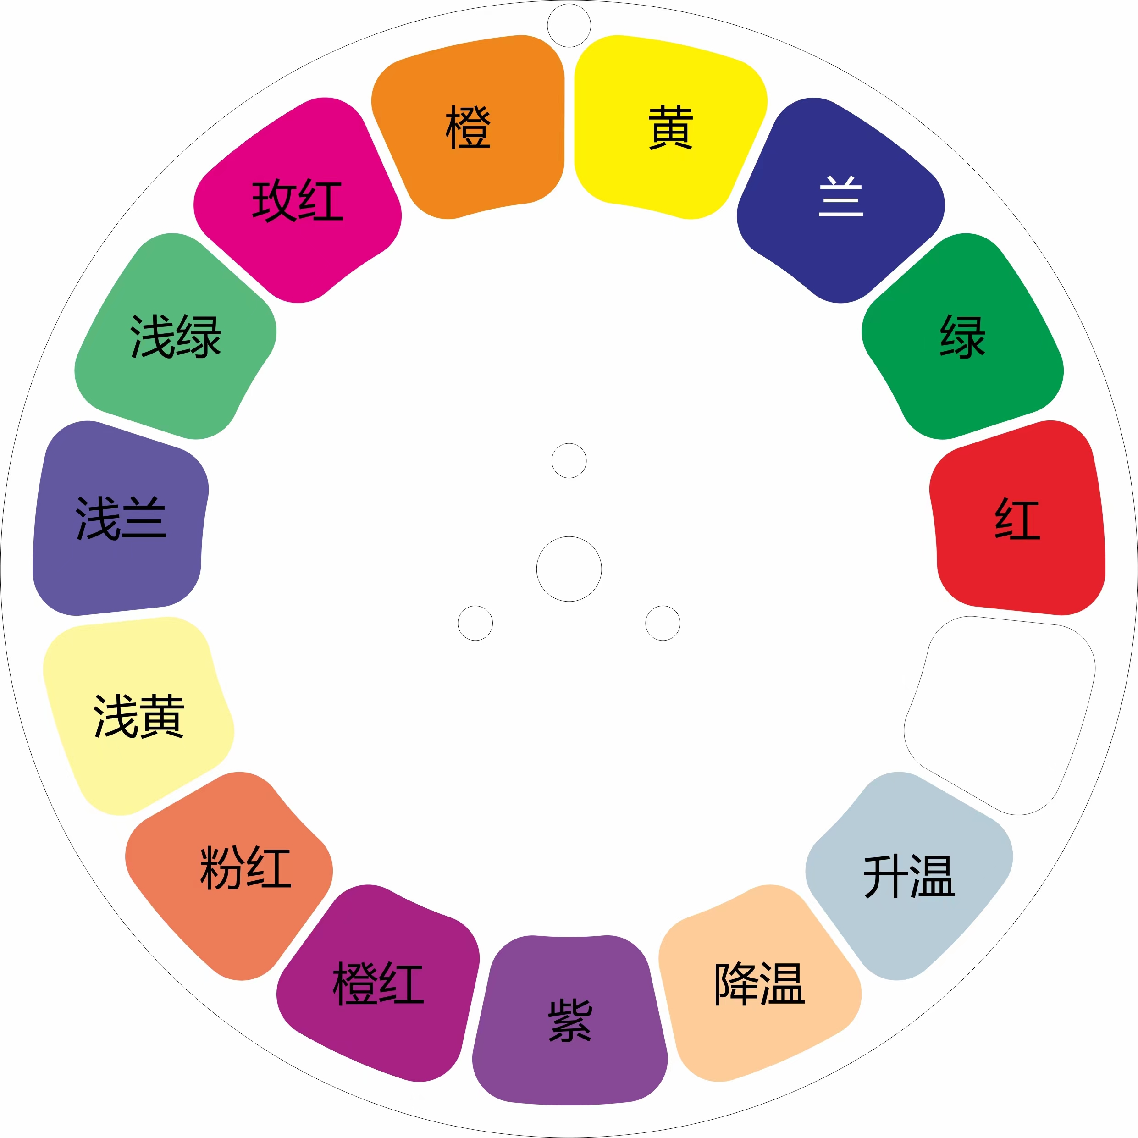
Frost & 6-color:
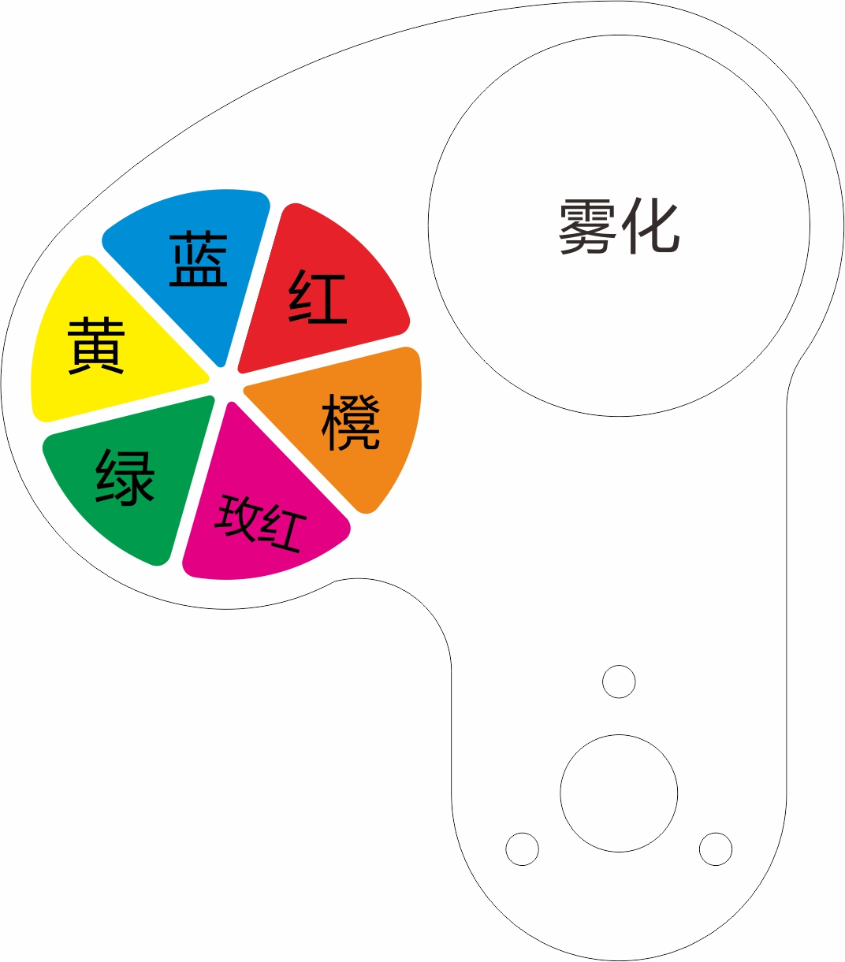

DMX-512 connection

Connect the provided XLR cable to the male 3-pin XLR output of your controller and the other side to the female 3-pin XLR input of the light.then connect the DMX signal to the first fixture to the 2nd fixture, after all fixtures are connected,

The signal cable should be two - core with screened cable with XLR input and output connectors. Please refer to the diagram below

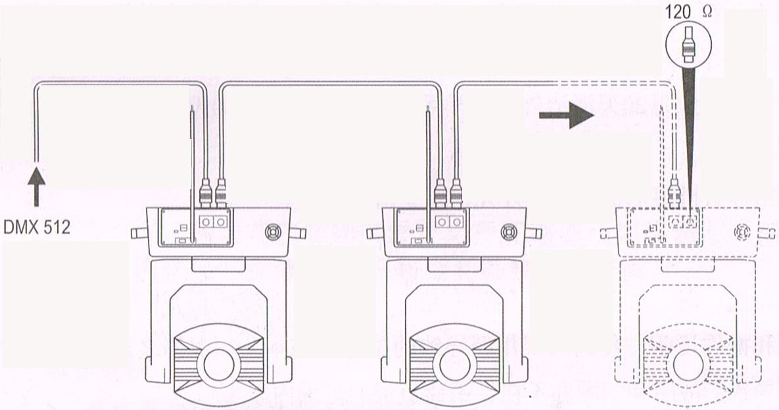

DMX terminator connection
If there are many lines or lights, it is recommended to use a DMX terminator to prevent DMX signal corruption, the DMX terminator is an simple XLR plug with a 120 Ω resistor connected between pins 2 and 3,which is then plugged into the output XLR socket of the last fixture in the chain.
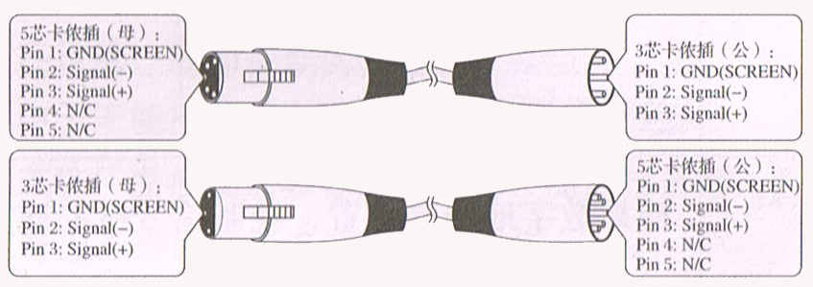
3-Pins connection
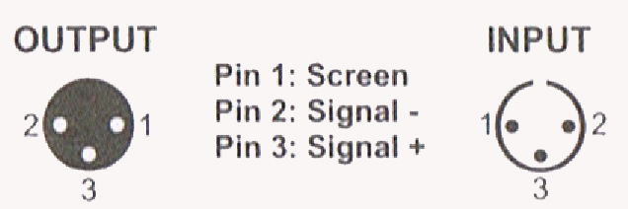
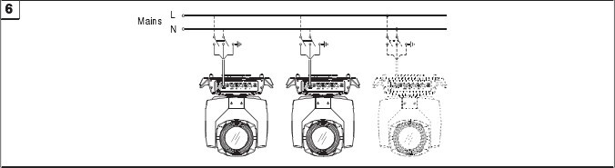
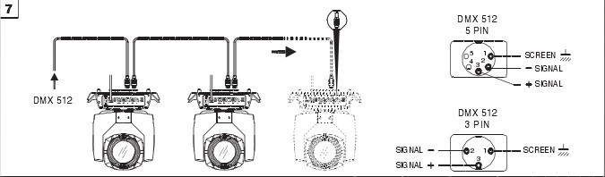

Cleaning and maintenance

Cleaning should be performed every 15-day period, by using a sponge which is dipped with alcohol, rather than wet cloth or other chemical liquid, to clean the mirror.

Cut off power before cleaning and maintenance!
CAUTION

Attention

Do not see directly light source when open the light, and make sure power off before do any installation or maintenance.
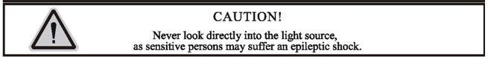
 Wires connection must be done professional person!
CAUTION

Cautions
Before delivery, this device has passed strict inspection, Please follow the user manual strictly for operation, if this fixture is damaged by improper operation and mistake, the fixture will be out of warranty, and manufacture or dealer won’t be responsible for it. In case of any technology change in this manual,we won’t advise in further .

Common issues instruction
Issues | Solve instruction
No power | Check power’s voltage
When power in, output light but the device cannot accept control signal | Check address setting and the control DMX cable connection well or not
The effect have light shadow | Check electronic focus DMX channel value, if it’s suitable distance
Light beam dim | The lamp maybe arrived end of using life, should change new lamp, and also check light source cleaning or not
Note: the maintenance should be done by the verified technician.

Warranty Card
This product is made of high-brightness transistor. We will provide 1 year warranty under the condition that user has operated the light normally and lifetime service. We won't provide warranty if the damage is caused by artificial or force majeure event. Cost of fittings should be charged by user if product need maintenance after 1 year .Please cut this warranty card and shipped it along with the product to our factory when applying for warranty.
Product：
Purchasing date：
Code of invoice：
Warranty date: From To
User’s name： Add：
Company： Tel：

